
ECOMONDO 2024: Daily Update, 6th November 2024

Bio-based industry for sustainable primary production in rural Mediterranean regions

The workshop taking place on the second day of Ecomondo (Rimini Expo Center, Italy, 5-8 November 2024) was marked by a truly international presence and highlighted the transformative potential of bio-based industries in fostering sustainability within rural economies worldwide. Researchers, policymakers, and industry leaders gathered to discuss how biotech advancements can benefit agriculture, forestry, and marine ecosystems.

A sustainable bioeconomy is essential to meet the global challenge of closing a 70% food gap, addressing pressing issues in biomass supply and demand. Marta Gomez San Juan from the FAO Office of Climate Change, Biodiversity, and Environment welcomed participants, noting, “Rural communities harvest, protect, and utilise biological resources, yet market access for new products is still an issue, even in the most advanced economies of the world. There are few regional and local bioeconomy strategies in place, and a certain lack in GIS tools that can support decision making”. Marta shared innovative case studies on supporting local livelihoods through equitable resource use, such as the Turning Fish into Fashion project in Kenya and the production of bio-based plastics from agave residues in Mexico. She also introduced FAO’s new global stocktaking study, study Bioeconomy for Food and Agriculture, as well as The Bioeconomy Toolbox, which supports the development of sustainable bioeconomy strategies.

Serenella Sala, European Commission, highlighted how safe, circular, and bio-based chemicals can drive innovation and support EU Green Deal targets like zero pollution and climate neutrality, emphasizing a holistic life-cycle measurement approach. Derek Nighbor, Canada’s Forest Products Association, shared national insights into sustainable forest management’s role in rural economic growth, Indigenous reconciliation, biodiversity, and safe and affordable housing. Samuele Ambrosetti, Bio-based Industries Consortium, Brussels, discussed bio-based industries as key enablers of a sustainable, competitive Europe, while Tomasz Calikowski, European Commission outlined how Circular Bioeconomy initiatives under the European Green Deal foster bio-based innovation through supportive policies and R&D activities.

Jim Philp, Policy Analyst and Member of the Ecomondo International Advisory Board, concluded the global session with a panoramic view of shifts in bioeconomy perspectives across different markets since 2009, citing examples from France, the US, and China. With 35 countries now implementing national bioeconomy strategies, Philp underscored the importance of a unified body to align these national initiatives with regional, international, and multi-stakeholder efforts.

The second part of the workshop focused on the multi-actor implementation of bioeconomy in the Mediterranean, featuring strategic initiatives including the G20 bioeconomy priorities under the Brazilian presidency presented by Professor Fabio Fava, President of the Ecomondo’s Scientific Technical Committee, EU-funded projects like BioInSouth and Biomodel4Regions, and innovative governance and regional projects supporting sustainable agriculture, forestry, and soil regeneration.

Innovation and Social Commitment for the EU Mission Restore our Ocean and Waters in the Mediterranean

One year after the launch of the Italian HUB, BlueMissionMed CSA gathered key Mediterranean stakeholders at Ecomondo in Rimini to propel the EU Mission "Restore our Ocean and Waters by 2030". Organised in collaboration with the European Commission, the National Research Council (CNR), and other strategic partners, the event focused on innovative solutions for safeguarding the Mediterranean Sea, aiming to bridge the gap between technological innovation and the business sector.

Demonstrations of cutting-edge solutions across various industries, presented in partnership with BlueMissionMed HUBs, reflected the region's geographical diversity. A highlight of the event was the presentation of the Society4Med award, which underscored the vital contributions of citizens and civil society in meeting the mission's goals.

The event featured the participation of high-level policymakers and included a dedicated matchmaking session to connect innovators with business experts and investors. Particular attention was given to public engagement, the promotion of community initiatives, and environmental education — key elements in fostering a collaborative approach to sustainability and health of Mediterranean waters.

ESG CEO Summit: Sustainable Future between Compliance and Competitiveness

The ESG CEO Summit tackled one of today’s most widely discussed topics: how to balance sustainable transition with the competitiveness of European businesses. Five years after the introduction of the Green Deal, the event evaluated the effectiveness of “European recipe” for a fair and sustainable transition. Surveys and forecasts unanimously show that environmental concerns will be at the core of all future strategies for both society and businesses globally. A clear indicator of this is the annual cost of environmental damage restoration, which is around €50 billion per year, projected to reach €1 trillion by the end of the century without policy changes.

Martina Malorni, Treasury & Credit Manager & Investor Relator, Italian Exhibition Group (IEG), opened the session, which was moderated by Luigi Monfredi, RaiNews. Prominent business leaders joined the discussion, focusing on the conditions necessary for a transition that will enhance European competitiveness over the next five years, with special attention to the challenges faced by both large enterprises and small businesses. Emphasis was placed on the critical need to align regulatory compliance with targeted investments, to mitigate adverse impacts on more vulnerable sectors.

“Unsustainable development is a luxury we cannot afford,” stated Carlo Cici, Partner & Head of Sustainability Practice at The European House-Ambrosetti. He emphasised, “The issue is not the direction of future development, but the speed at which we can implement it, with financing as the business driver and motivator for businesses in this transition.”

Regulation alone is insufficient to accelerate the transition; it must be complemented by measures to simplify access to sustainable finance for SMEs, invest in R&D, develop sector-specific strategic plans, and strengthen ESG competencies.

NB! All events organized by Ecomondo’s Scientific Technical Committee support the European initiative “No Women No Panel”.

PRESS CONTACT - ITALIAN EXHIBITION GROUP
head of media & corporate communication: Elisabetta Vitali; press office manager: Marco Forcellini, Pier Francesco Bellini; international press office coordinator: Silvia Giorgi; press office coordinator: Luca Paganin; press office specialists: Nicoletta Evangelisti, Mirko Malgieri; media@iegexpo.it

MEDIA AGENCY

Hill & Knowlton
Francesca De Angelis, +39 342 7460159 - francesca.deangelis@hillandknowlton.com
Valentina Corsi - +39 3270425730 - valentina.corsi@hillandknowlton.com
Alessio Ricciuto - alessio.ricciuto@hillandknowlton.com

Stampa Estera - Oksana Smirnova - smirnova.consultant@hillandknowlton.com

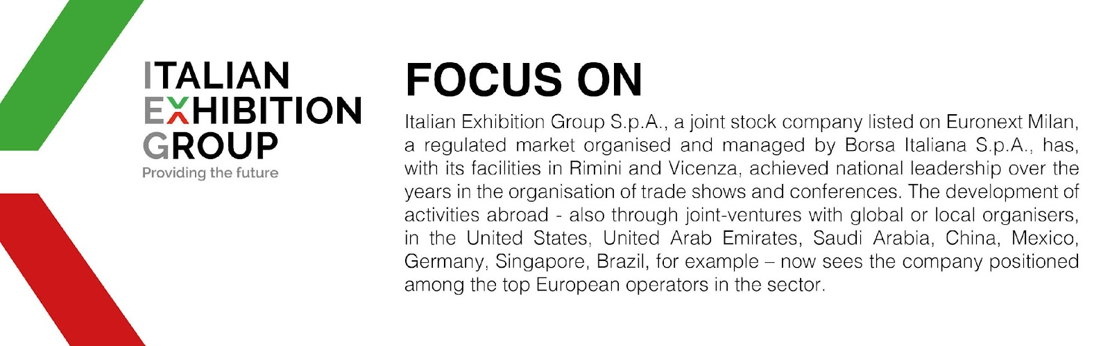

This press release contains forecast elements and estimates that reflect the management’s current opinions (“forward-looking statements”), particularly regarding future management performance, realization of investments, cash flow trends and the evolution of the financial structure. For their very nature, forward-looking statements have a component of risk and uncertainty, as they depend on the occurrence of future events. The effective results may differ (even significantly) from those announced, due to numerous factors, including, only by way of example: food service market and tourist flow trends in Italy, gold and jewellery market trends, green economy market trends; the evolution of raw material prices; general macroeconomic conditions; geopolitical factors and evolutions in the legislative framework. Moreover, the information contained in this release does not claim to be complete, and has not been verified by independent third parties. Forecasts, estimates and objectives contained herein are based on the information available to the Company as at the date of this release.

